Aging effects on functional brain connectivity by Magnetic Resonance Imaging

João P. S. Silva¹, Renata F. Leoni², Antonio C. dos Santos²
¹Inbrain Lab, Department of Physics, FFCLRP, University of Sao Paulo, Ribeirao Preto, Brazil, ²Department of Medical Clinic, FMRP, University of Sao Paulo, Ribeirao Preto, Brazil

Introduction: Recently, the effects of aging on human brain tissue, mainly how changes in brain functionality happen through time have been extensively discussed¹. However, there is still no agreement on which brain regions have altered Functional Connectivity (FC) and how it is related with healthy aging. Therefore, this study aims to investigate the Resting State Networks (RSNs) and FC in healthy aging using functional Magnetic Resonance Imaging (fMRI).
Materials and Methods: Twenty subjects were included in this study: ten healthy young (6M/4F, mean age = 24.2±3.2 years) and ten healthy elderly (4M/6F, mean age = 60.2±8.3 years). Images were acquired in a Philips Achieva 3T System, using a 32-channel head coil for signal reception. For anatomical reference, images were acquired using a 3D T1-weighted GRE sequence, with the following parameters: TR/TE = 7/3 ms, flip angle = 8°, matrix = 240 x 240, FOV = 240 x 240 mm², 160 1-mm slices. For functional evaluation at resting state, images based on BOLD contrast were acquired using a 2D EPI sequence, with the following parameters: TR/TE = 2000/20 ms, flip angle = 90°, matrix = 80 x 80, FOV = 240 x 240 mm², 31 4-mm slices, gap = 0.5 mm, number of dynamics = 200. Images were processed using own routines developed in MATLAB (MathWorks, Natick, MA) and SPM12 routines. Group ICA of fMRI Toolbox (GIFT) was used to assess the spatial distribution of RSNs. T-tests corrected for multiple comparisons were used to show differences in RSNs maps between subject groups (p-FDR < 0.05), and Dice similarity coefficients were calculated to assess the similarity between maps. For FC evaluation, fMRI data was analyzed within the Conn toolbox considering all brain regions in Harvard-Oxford atlas as seeds.
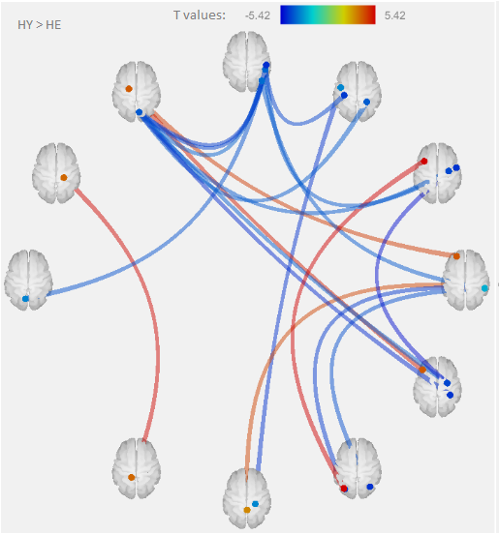
Results: Statistical parametric maps from both groups showed the following RSNs: default mode network, visual, auditory and left executive control. However, a voxel-wise analysis comparing RSNs maps between groups showed differences in spatial distribution. Alterations in FC were observed in healthy aging, mainly between regions involved in memory, planning, attention, visual processing and language (Figure 1).
Discussion: RSNs maps were more spread in elderly, showing that, with aging, the brain may recruit new areas as a form of compensation, leading to a loss of expertise².
Conclusion: So far, the results of the present study indicate a significant alteration of FC and differences in spatial distribution of RSNs in healthy aging. Further analysis and greater group sizes with allow more understanding on the relationship between aging and changes in brain functionality.
Figure 1: Red and blue lines show, respectively, higher and lower correlations for the young group compared to the elderly group. Statistical threshold was set at p < 0.05 (FDR-corrected).

References: [1] Ferreira, L. K. et al., Neurosci. Biobehav. Rev. 37(3):384-400, 2013; [2] Sala-Llonch et al., Front. Psychol. 6(663), 2015.

