Computation of Brain Midsagittal Plane through DTI-Based Divergence Map

G. R. Pinheiro, G. S. Cover, L. Rittner
Medical Image Computing Laboratory (MICLab), School of Electrical and Computer Engineering (FEEC), UNICAMP

Introduction: The Corpus Callosum (CC) is a white matter structure that interconnects both brain hemispheres. Many studies have shown the correlation between CC alterations and neurodegenerative diseases. In order to properly analyze the CC structure in 2D studies, the midsagittal slice selection of the brain is required, and it is usually identified by the diffusion properties [1] observed in the interhemispheric fissure, being applied to the midsagittal plane (MSP) of the whole brain [2]. This work proposes the CC midsagittal plane computation directly on Diffusion Tensor Imaging (DTI) through the divergence map, a scalar map that represents the quantity of a vector field's source or sink at each point. The method explores the well-organized white matter in the CC and finds the plane with maximum fibers divergence, differently from MSP, which is based on structural characteristics of the brain, such as symmetry and inter-hemispheric fissure localization. Experiments have shown that the computed plane is invariant to CC misalignment relative to the image acquisition plane, and low sensitivity to the parameters selection.

Materials and Methods: Our image dataset was composed by DTI from two subjects obtained in the axial plane (2.0 mm thickness, 1.0 x 1.0 mm, 32 directions) at Hospital de Clínicas of UNICAMP. Initially, a manually cropped volume of (18x83x36) voxels around the CC is loaded and a divergence map is computed over many directions. For divergence map computation, we apply the algorithm described in [3]. The plane computation is done using an iterative fitting of least squares method and removing 10% of the points placed far away from the computed plane. This step is re-executed until all points are in 2 voxels range from the plane. In the end, the desired plane is the plane where the direction of interest is the one perpendicularly closest to the plane normal vector.

Results: The proposed method for midsagittal plane computation was tested over two subjects with similar and satisfactory qualitative results (Fig. 1). In one of them, the MSP was aligned with the vector [0.999805x, -0.019226y, 0.004409z], while the other was aligned with the vector [0.99628x, 0.068077y, 0.052832z].

Discussion: The method founds the plane of maximal divergence (inflexion) of the CC fibers. As this plane lies in the CC symmetry plane, this method is an option for the brain midsagittal slice selection.

Conclusion: This work implements a mid-sagittal plane computation method, showing that the plane is invariant to CC misalignment relative to the image acquisition plane, and low sensitivity to the parameters selection.

References: [1] Rittner L et al. Rev. Bras. Eng. Biom., vol. 30(2), pp. 132-143, 2014. [2] Basser P. et al. J. Magnetic Resonance, Series B, 111(3), pp. 209-19, 1996. [3] Pinheiro G. R. et al. Conf Proc IEEE Eng Med Biol Soc (EMBC), IEEE 38th Annual International Conference, 2016.

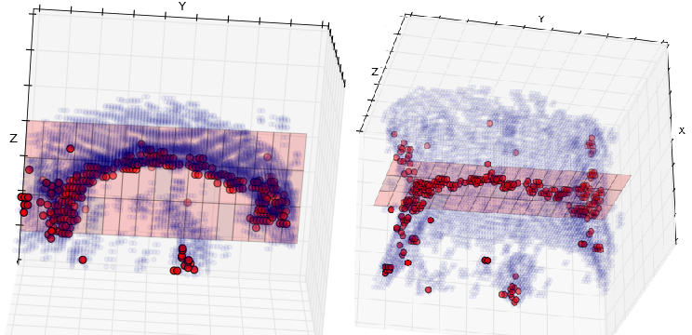

Figure 1. Computed midsagittal plane seen in two different perspectives. Red dots are points with maximum absolute divergence, blue region is a rough segmentation of the white matter, and red surface is the obtained plane.

