Multimodal Visualization of DTI Glyphs for Diffusivity Tensor Assessment

R. Voltoline¹, C.L.Yasuda², S.-T. Wu¹,
¹School of Electrical and Computer Engineering, UNICAMP, ²School of Medical Sciences, UNICAMP

Introduction: Through diffusion of the water molecules, diffusion tensor imaging (DTI) can reveal information about the structure of tissues at a macroscopic level, allowing the assessment of the neural tracts and the connectivity of the brain. DTI has, therefore, emerged as a promising tool for studying some diseases, such as ischemic stroke and neural tract disorder [1]. However, it is an approximate technique and relies strongly on the signal sampled and the sample resolution. When tensors are not well-estimated, it can lead to misinterpretation. Glyphs may be used for quality control of a second order diffusion tensor estimation [2]. Superquadric glyphs have been shown to outperform with respect to directional ambiguity and spatial perception [3]. Co-localization of the glyphs with the anatomical structure can improve the visual assessment. The goal of this work is to develop a multimodal visualization of superquadric glyphs and T1-weighted magnetic resonance images (MRI).

Materials and Methods: For each visible voxel of a DTI volume, we draw the corresponding superquadric glyph in its center. The glyphs are resized with the smallest dimension of the voxel and colored with a novel colormap we proposed [4]. Each diffusivity tensor is co-located with the cerebral structure through the co-registration [5] of the non-diffusion weighted (b=0) and the T1-weighted MRI. The robust estimator with outlier rejection (RESTORE) [6] is used to obtain the second order positive semidefinite tensors from the diffusion-weighted images (DWI). The algorithm is integrated into the in-house developed VMTK [7].

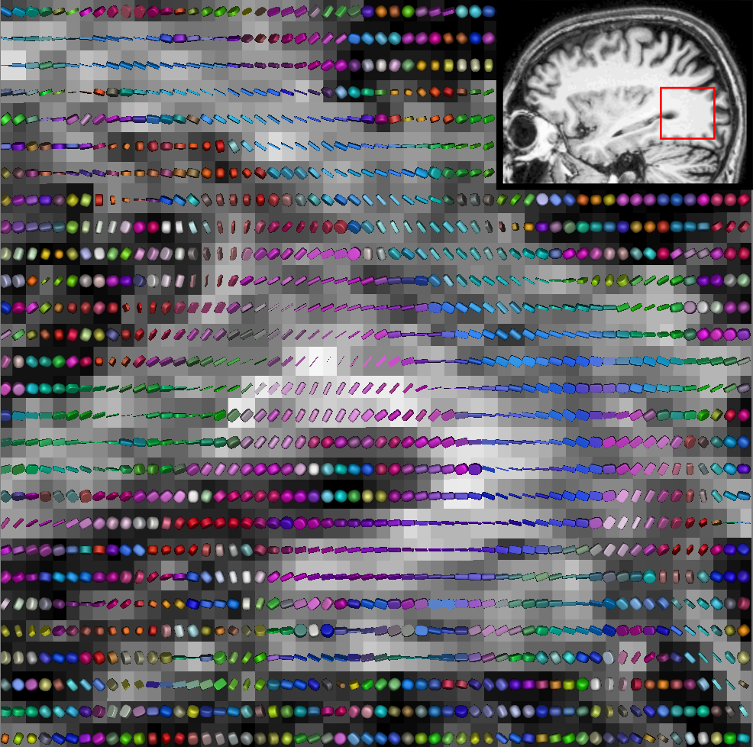
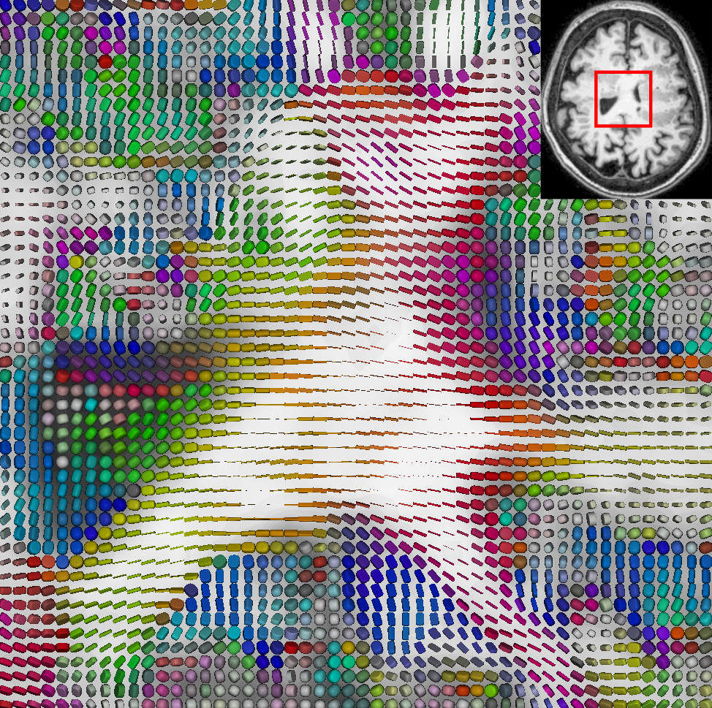
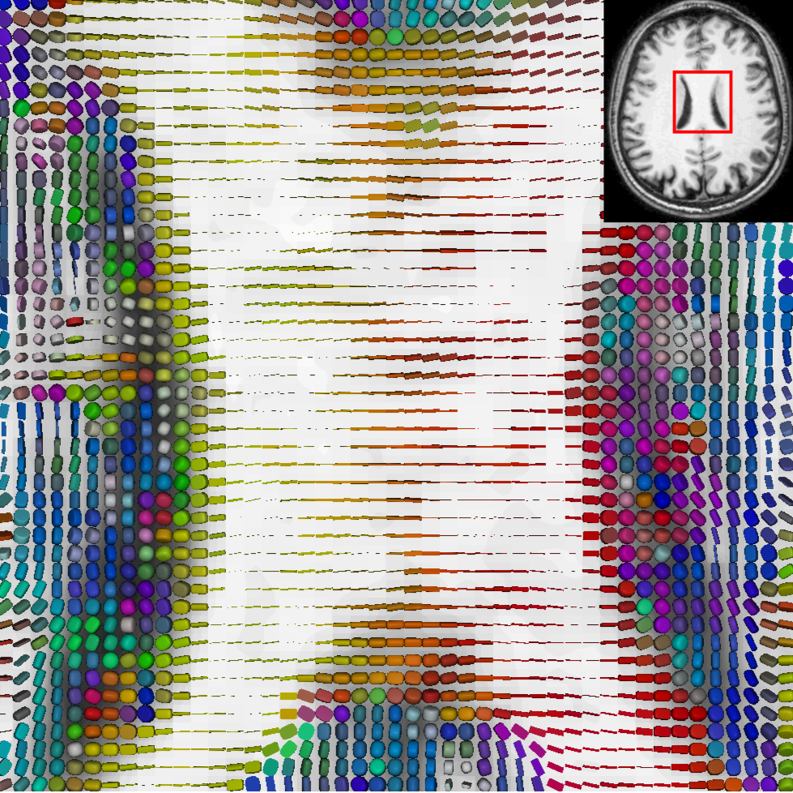
Results: The co-registered axial images of MRI-T1 (in grayscale) and DTI (in colored glyphs) display the diffusivity in the corpus callosum of a healthy control (a) and a patient suffering from subcortical band heterotopia (b). The glyphs of anisotropic DWI voxels are illustrated in the sagittal view of the inferior longitudinal fasciculus (c). Their corresponding regions in MRI-T1 slices are highlighted on the images at the top right corner. Together with the anatomical knowledge, clinicians can visually assess the quality of the estimated tensors.
(c)
(b)
(a)

Discussion: The procedure is implemented on a GPU, making the images conducive to the visual exploration. Because voxels are mostly anisotropic, the occupancy of the glyphs on the screen is suboptimal (Figure c). This problem can be overcome by resampling either the DWI volumes or the corresponding tensor volume. Nevertheless, superquadric glyphs are not appropriate for visualizing higher order tensors that are promising for representing fiber crossing and fiber kissing.

Conclusion: We proposed a way to display estimated diffusivity tensors that is useful not only in assessing the estimated tensors but also in evaluating the diffusivity in a larger tensor field as well. Despites limitations, this visualization tool may be helpful in the reconstruction of neural tracts.

References: [1] Lerner A. et al, World Neurosurg. 2014 Jul-Aug;82(1-2):96-109; [2] Soares JM. et al, Front Neurosci. 2013 Mar 12;7:31; [3] Kindlmann G., IEEE VGTC Symposium on Visualization. 2004: 147-154; [4] Wu S-T, Voltoline R, Yasuda CL., Computers & Graphics; v. 60, p. 66-75, Nov 2016; [5] Valente AC, Wu S-T., Sibgrapi 2012, pages 1–6. 2012; [6] Chang LC, Jones DK, Pierpaoli C., Magn. Reson. Med. 2005 May;53(5):1088-95; [7] VMTK. http://www.dca.fee.unicamp.br/projects/mtk/wu_loos_voltoline_rubianes/index.html

