A Voxel Based Morphometry Study of treatment-resistant patients with Generalized Epilepsies
M. S. Polydoro¹, D. S. Garcia¹, M. K. Alvim¹, A. Ishikawa¹, L. Montanher¹, M. E. Morita¹, F. Cendes¹, C. L. Yasuda¹
¹Neuroimaging Laboratory, FCM, UNICAMP

Introduction: Although structural abnormalities in gray matter (GM) and white matter (WM) have been described in generalized epilepsies (GE) (1, 2, 3), the impact of treatment response has not been completely investigated. Therefore, in this study, we compared refractory and seizure-free subjects to differentiate patterns of structural alterations.

Materials and Methods: Voxel Based Morphometry (VBM) analyses were performed on T1 weighted images with MATLAB2014b/SPM12/CAT12, comparing controls (65 subjects), and two groups of patients (28 seizure-free [SZ-free] and 37 refractory). Individual maps of GM and WM were extracted, modulated, smoothed and normalized. Statistical analyses with CAT12/SPM12 included separate T-tests between patients and matched controls, with contrasts designed to highlight areas of grey and white matter atrophy in patients.

Results: Refractory patients present a more widespread pattern of atrophy, especially in GM, which included extensive areas in cerebellum.

Grey matter |  | White matter
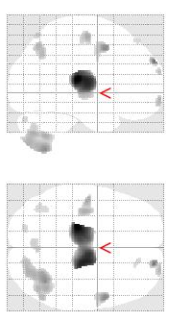 | 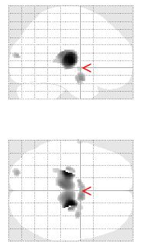 | 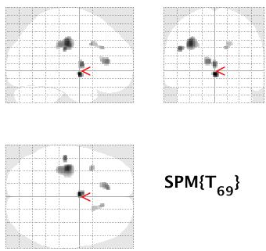 | 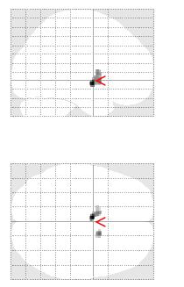
Atrophy in refractory | Atrophy in SZ-free | Atrophy in refractory | Atrophy in SZ-free

Discussion: As expected, atrophy in thalami was observed in both groups, however, a more severe pattern of atrophy was detected in refractory patients, suggesting a negative impact of seizures on the brain integrity.

Conclusion: This study showed that treatment-resistant and seizure-free patients have different patterns of brain abnormalities. Further studies are necessary to investigate possible interactions between subtypes of seizures and structural brain abnormalities.

References: (1) Bernhardt, B.C., et al., 2009. Thalamo-cortical network pathology in idiopathic generalized epilepsy: insights from MRI-based morphometric correlation analysis. Neuroimage. 46, 373-81. (2) Betting, L.E., et al., 2006a. Voxel-based morphometry in patients with idiopathic generalized epilepsies. Neuroimage. 32, 498-502. (3) Betting, L.E., et al., 2006b. MRI volumetry shows increased anterior thalamic volumes in patients with absence seizures. Epilepsy Behav. 8, 575-80.

