Postoperative dynamic changes on contralateral hippocampus: manual volumetry and relaxometry analyses

Amaral, I., Silva, B. F., Ishikawa, A., Garcia, D. S., Morita, M. E., Alvim, M.K, Ghizoni, E., Tedeschi, H., Cendes, F., Yasuda, C. L
¹Neuroimaging Laboratory, FCM, UNICAMP

Introduction: Despite good surgical control for approximately 50-60% of operated patients¹, almost one third persist with seizures. Unfortunately, post-operatory dynamic changes on contralateral hippocampus is not entirely known^{2,3}, neither its correlation with surgical outcome. Here we investigated alterations in volume and relaxometry time after temporal lobe (TLE) surgery for refractory epilepsy.
Materials and Methods: We evaluated longitudinally 37 patients with unilateral hippocampal atrophy (31 controlled and 6 refractory), who underwent preoperative/postoperative MRI in a 3T scanner. Blinded, manual hippocampal volumetry and T2 relaxometry measurements were performed with free software Display (Montreal Neurological institute) and Aftervoxel, respectively. Statistical analyses were performed with SPSS22 (repeated measures ANOVA) to investigate deterioration after surgery (groups controlled and refractory).
Results: At long-term evaluation, there was significant atrophy of contralateral hippocampus in both groups of patients (controlled, p<0.001, and refractory=0.002) (Fig 1 A/B). On contrary, relaxometry analyses revealed no significant changes for both groups; however, there was a trend for increase for refractory patients (Figure1 C/D)

 | 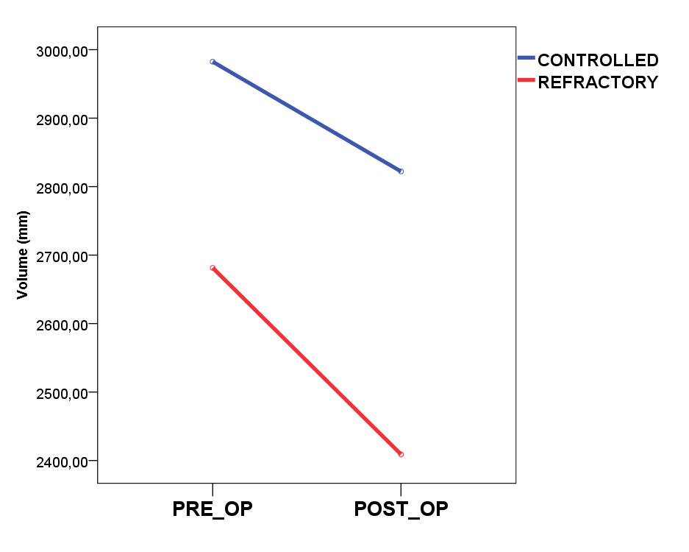
- Manual volumetry on 3D images | - Comparison of hippocampal volumes
 | 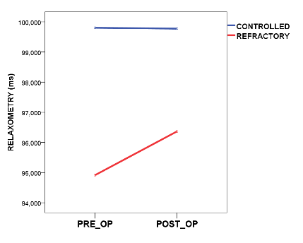
- T2 relaxometry measurement | D. Comparison of T2 relaxometry
Figure 1. Longitudinal analyses of hippocampal volume and relaxometry pre and postoperatively

Discussion: We observed significant volumetric reduction of contralateral hippocampus, regardless surgical outcome, seen in a previous study⁴. Interestingly, no significant changes were detected on T2 relaxometry of the same subjects as seen in preoperatory analyses. These findings suggest that the volumetric reduction may not necessarily impact its function; it is also possible that the small number of refractory patients may have hampered significant increase.
These dynamic changes require further investigation and correlations with cognitive assessment.
Conclusion: Our data suggest that significant volumetric reduction may occur after surgery, however may not be associated with increase of T2 relaxometry.

References: [1] Yasuda, C.L., et al., 2006. 15, 35-40. [2] Cendes, F., et al., 1993. Ann Neurol 34, 795-801; [3] Elliot, A.C., et al., 2016. Epilepsy Research 125 (2016) 62-71; [4] Fernandes, D.A., et al., 2014. Epilepsy Behav 36, 108-14;

