Improved SISCOM for more accurate location of seizure-onset zone
L. S. Watanabe^{1,3}, S.-T. Wu¹, B. J. Amorim²,
¹Computer Engineering and Automation Dept., FEEC, Unicamp, ²Division of Nuclear Medicine, FCM, Unicamp, ³Clinics Hospital of the University of Campinas

Introduction: Patients with drug resistant epileptic seizures are candidate to surgery resection of the epileptogenic focus. For removing the seizure-producing area from the brain and limiting the spread of seizure activity, its precise localization is essential. SISCOM (Subtraction Ictal SPECT Co-registered to MRI)[1] is a known efficient technique for identifying the epileptogenic focus including cases of nonlesional and extra-temporal MRI-negative epilepsies. This technique takes advantage of transient focal increase in cerebral blood flow during a seizure in comparison with the hipoperfusion or normoperfusion during the interictal state. Both states are captured by SPECT (Single-Photon Emission Computed Tomography) scans. We improved the flow of the algorithm presented in [3] by improving the rigid co-registration and the skull stripping.

Materials and Methods: The T1-weighted MRI and the ictal and interictal SPECT exams were acquired, respectively, in the Philips Achieva 3T and in the Siemens Symbia T scanners. The original SISCOM algorithm from Mayo Foundation comprises 6 steps, of which two have been improved: 1) noise removal is performed with a brain extraction tool ROBEX [2] rather than threshold-based filtering, therefore original SISCOM brain segmentation and hole filling steps could be bypassed in our approach; 2) ictal SPECT, interictal SPECT and MRI coregistration is performed with an improved mutual information based technique[4] that was validated with the Vanderbilt Database[5], so the subtraction of the ictal and interictal states becomes more accurate.

Results: The preoperative T1-weighted MRI-negative exam of a patient with histologically proven Type IIa focal cortical dysplasia is shown in Figure (b). The normalized interictal and the ictal SPECT volumes are presented, respectively, in Figure (c) and (d). They are colored with rainbow palette, where the red color indicates high perfusion and the blue low perfusion. The subtraction of these two volumes is depicted in Figures (e,f) in which the epileptogenic focus in the right mesial frontal lobe becomes visually perceptible. This finding agrees with the medical signs and other exams as eletroencefalography. Note that Figure (f) shows the difference volume fused with MRI for anatomical reference. Figure (g) shows the postoperative T1-weighted MRI scan of the resected region which has been submitted to pathological analysis.

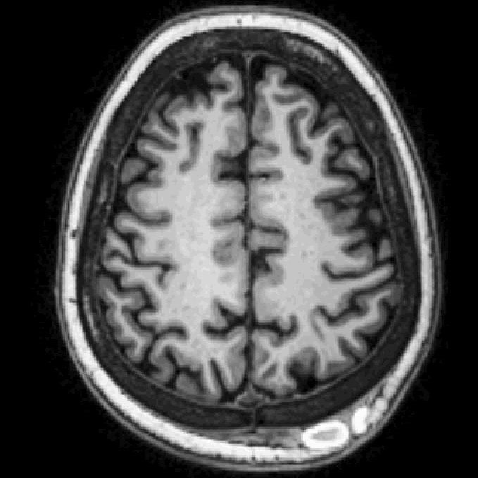  (a) | 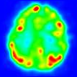  (b) | 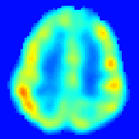  (c) | 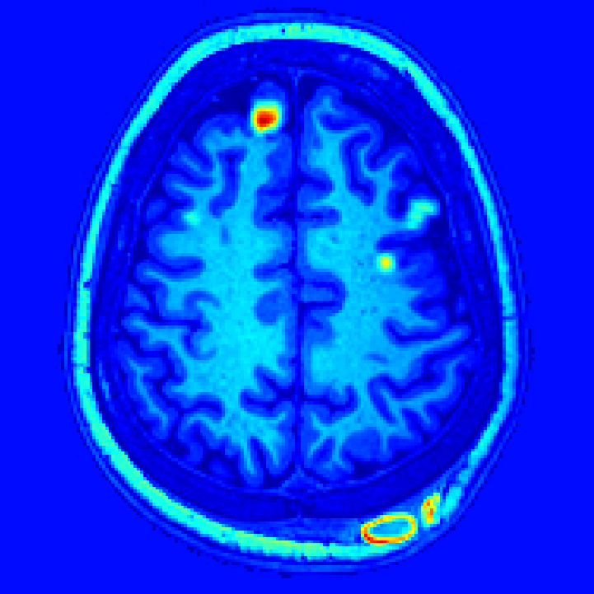  (d) | 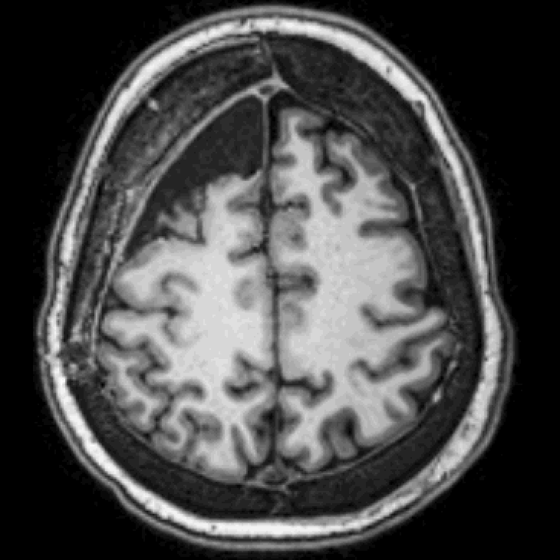  (e)

Discussion: Improving the brain extraction and the co-registration of multimodal volumes leads more precise outcome in the difference of SPECT ictal and interictal. When co-registered with an anatomical reference the lesion location can be assessed more acurately.

Conclusion: This improved subtraction algorithm has shown promising results. However, it is important to assess its clinical value in the detection of subtle lesions.

References: [1] O’Brien TJ et al., Neurology 50(2): 445-454, 1998; [2] S. Roy et al., 8th ICAPR, Kolkata, 1-6, 2015; [3] Available: http://www.synapticom.net/images/pdf/SISCOM_V_4.0.pdf; [4] Ting W.S. et al., SIBGRAPI, 41-48, 2014; [5] Available: http://www.insight-journal.org/rire/.

