Study of the Cortical Connectivity in Altered States of Consciousness: MEDITATION
TOUTAIN, T.G.^{1,2,3,4}, PORTO, J. A.M.^{1,4},BAPTISTA, A. F.^{2,4} , JAPYASSÚ, H. F.^{3,4}, ROSÁRIO, R. S. ^{1,4}, MIRANDA, J. G. V. ^{1,4}
¹ Núcleo de Inovação Tecnológica em Reabilitação – NITRE; ² Núcleo de Estudos em Saúde e Funcionalidade - NESF; ³Núcleo de Etologia e Evolução – NuEVo; ⁴Universidade Federal da Bahia – UFBA

Introduction: Although meditation is known for changing the consciousness’s state [1], little is known about the dynamics of the changes in brain connectivity. Here we analyse functional networks of brain dynamics [2] (Time Varying Graph – TVG – (Figure 01)), comparing cortical activity and stability during meditation (MD) and relaxation (RL), considering experienced meditators of two groups, Raja Yoga (RY - from Brahma Kumaris) and Gurdjieff (GD), both from Salvador – Bahia/Brazil. Understanding the function features of the meditation state in time domain can help in a deeper understanding of the mechanisms that make this practice a powerful tool in promoting health and well-being.

Materials and Methods: This study included 16 experienced meditators from RY (n=8) and GD (n=8). EEG data were recorded with BrainNet BNT 36, using 30 electrodes (International 10-10 system)[3]. We used NuPrep Waves Gel® to improve the conductivity and Contact-Cream® to fix the electrodes on scalp. The sample rate was 600 Hz, electrode reference in Cz, and the impedance was between 0 and 5 Ω. Protocol: Base Line (BL) - 5 minutes; RL - 6 minutes and 12 minutes of traditional meditation (RY or GD) with eyes closed. Only one run was done for each subject. Data were analyzed through TVG, using motifs synchronization [4]. The study was approved by the Ethics and Research Committee of Health Sciences Institute of Federal University of Bahia.

Results: According to [4] the time electrodes remain synchronous is measured by the weighted degree (kp) of the added static network of individuals TVG. Results show kp increase during meditation (Wilcoxon paired p=0.044). This is mainly due to Gurdjieff meditators (T-Test p=0.031), since Raja Yoga meditators do not show changes in brain dynamic connectivity (Wilcoxon paired p=0.484). This difference can be view in figure 02. Meditation also increased cortical stability (measured as the coefficient of variation of the clustering coefficient in time, T-Test, p=0.024), meaning that the topology of the network’s brain stabilizes during meditation for both groups.
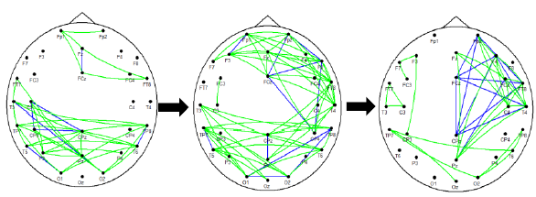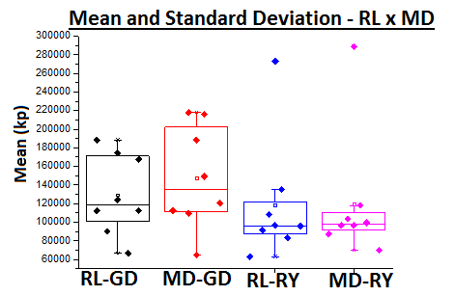
Figure 01: TVG. Edges represents synchronization between electrodes. Green lines indicate arrows (directed synchronization), and blue lines edges (undirected synchronization). | Figure 02: Differences in Kp of relaxation (RL) and meditation (MD). Values are expressed as mean and dispersion values. GD: Gurdjieff, RY: Raja Yoga. Each point represents a subject.
Discussion: Previous studies with EEG and fMRI have indicated that meditation and relaxation are associated with different brain dynamics [5] for quantitative EEG and fMRI. However, in experienced meditators, these states can be similar [6]. The result found in RY group is probably due the intention of the meditation and way of life. The GD group does exercise regularly with synchronized movements and use deep relaxation in their meditative practice.

Conclusion: The present study confirmed that MD and RL are different, in the Gurdjieff group, but these results aren’t the same for Raja Yoga group. In MD state, analyzed by agglomeration coefficient, the cortical topology keeps more stable than RL state does.

References: [1] TART, C. T. 3º edição. First Harper Collins edition. 1990. [2] REIJNEVELD, J. et al., Clin.Neurophysiol. 118, 2317–2331. 2007. [3] JURCAK, V., et al., NeuroImage. 2007. [4] ROSÁRIO, R. et al.,Physica A: Statistical Mechanics And Its Applications, 2015. [5] LAGOPOULOS, Jim, et al. The Journal of Alternative and Complementary Medicine, Volume 15, Number 11, pp. 1187–1192; 2009.[6] BREWER, J.A, et al. Proceedings of the National Academy of Sciences of the United States of America. 108, 20254–9. 2011.

