Abnormal Inter-Intranetwork Connectivity in patients with Generalized Epilepsies

D. S. Garcia, M. Polydoro, M. K. Alvim, A. Ishikawa, B. M. Campos, L. L. Monthanher, M. E Morita, F. Cendes, C. L. Yasuda
¹Neuroimaging Laboratory, FCM, UNICAMP

Introduction: Generalized epilepsies (GE) present heterogeneous semiology of seizures and have been considered as a benign disorder. However, several studies have found structural and functional abnormalities such as gray and white matter atrophies/excesses, as well as increased/decreased connectivity in some brain resting state networks (RSNs). Unfortunately, it is not clear how dysfunctional are the interactions among these RSNs. Therefore, the purpose of this study is to compare interactions of 12 RSNs (from resting-state functional-MRIs).

Materials and Methods: The 12 RSNs were parcellated in 70 regions of interest (ROIs). Sixty-one subjects with generalized epilepsy and sixty-two healthy controls were matched by age and gender. We used UF2C-toolbox (running on MATLAB2014 and SPM12) for image preprocessing, ROI parcellation and statistical analysis, including intranetwork and internetwork connectivity.

Results: We identified both decreased and opposite correlations in the GE patients RSNs as presented in Table 1. Figure 1 reveals alterations concentrated predominantly on left side.

Reduced Connectivity:  (Controls>Patients)  Posterior Salience with:  - Basal Ganglia  - Visuospatial  Visual with:  - Dorsal DMN  Left Executive Control Network with:  - Visuospatial  - Ventral DMN  Posterior Salience with Posterior Salience  Visuospatial with Visuospatial  Opposite Connectivity:  (Patients  -(Controls))  Visuospatial with:  - Basal Ganglia  - Posterior Salience  - Ventral DMN | 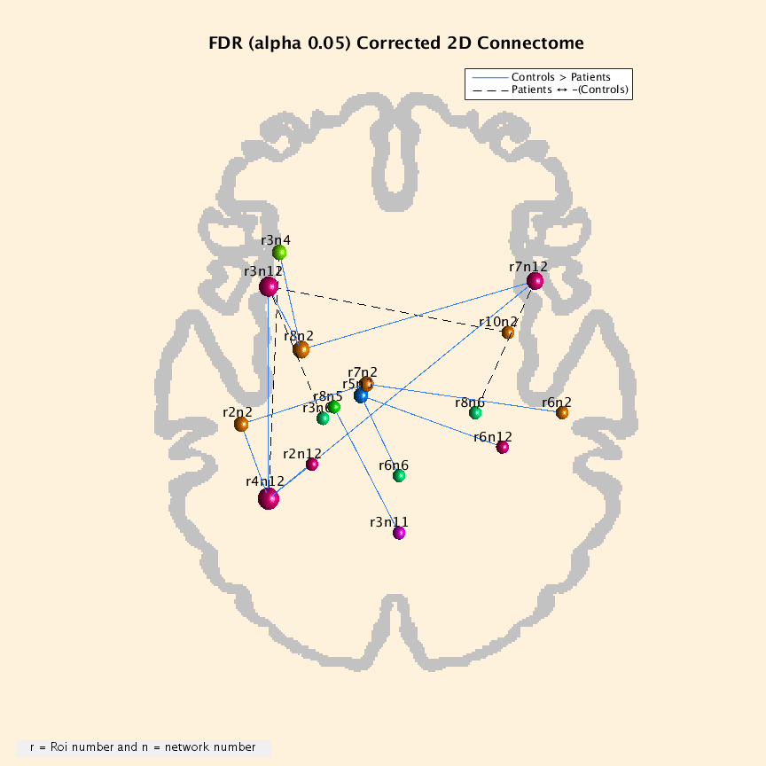
Table 1. Key findings from internetwork and intranetwork connectivity analysis between 61 GE subjects and 62 healthy controls | Figure 1. Graph with relative decresead and opposite connectivity hubs between patiens and controls.
Discussion: These results suggest that Posterior Salience and Visuospatial networks present most of altered interactions in GE patients. Such alterations corroborate with previous findings that revealed abnormalities in frontal, parietal and thalamic regions.
Conclusion: As an exploratory study, we found extensive alterations in GE functional networking; however, further research is necessary to investigate the impact of seizure controls on dysfunctional networks.
References: [1] Zhang, Z. et al., 2011. Altered functional-structural coupling of large-scale brain networks in idiopathic generalized epilepsy. Brain. 134(Pt 10):2912-28.

