Cortical surface analysis in patients with Generalized Epilepsies

D. S. Garcia, M. K. Alvim, M. Polydoro, A. Ishikawa, L. L. Montanher, M. E. Morita, F. Cendes, C. L. Yasuda¹
¹Neuroimaging Laboratory, FCM, UNICAMP

Introduction: Volumetric and surfaced based analysis have been extensively used on focal epilepsies to quantify brain alterations. However, in generalized epilepsies (GE) these methods are not commonly utilized and little is known about cortical thickness abnormalities. Thus, the aim of this study is to evaluate the extent of cortical damage in patients with GE using a new variant of computational analysis.

Materials and Methods: Surface-Based Morphometry (SBM) analyses were performed on T1 weighted images with MATLAB2014b/SPM12/CAT12 (http://dbm.neuro.uni-jena.de/cat12/), comparing 67 GE PATIENTS with 68 age and gender matched CONTROLS. This technique is completely automatic and allows measurement of cortical thickness as well as reconstructions of the central surface in one-step. Statistical analyses with CAT12/SPM12 included separate T-tests between Left and Right hemispheres of patients and matched controls, with contrasts designed to highlight areas of atrophy in patients. Reported results have minimum T-statistic of 3, with at least 10 voxels in each cluster.

Results: Patients with GE presented reduced cortical thickness compared to healthy control, more widespread in the left hemisphere, particularly in the frontal lobe. In addition to alterations in frontal regions (particularly in the precentral gyrus), lower cortical thickness was detected in occipital and mainly in anterior temporal lobe (Fig1).

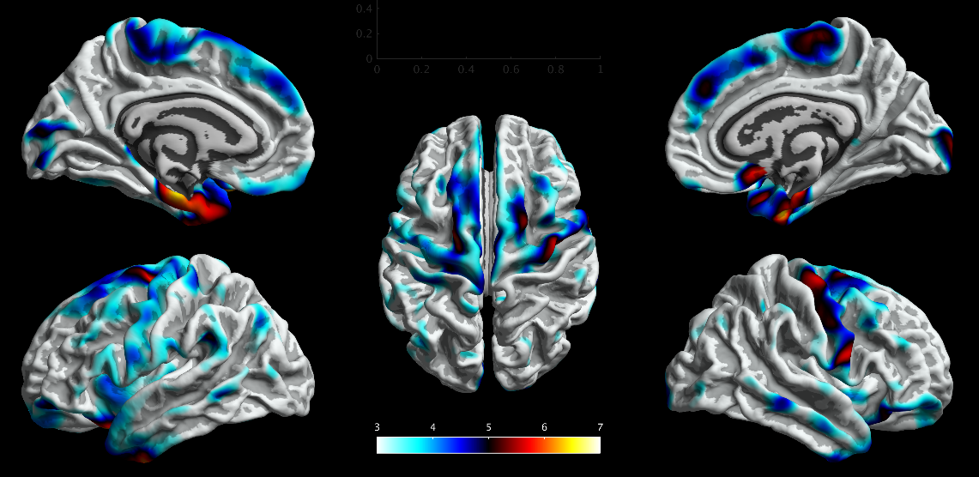
Fig. 1 Surface-based analysis of local cortical thickness. GE patients present widespread, bilateral reduction of cortical thickness.

Discussion: This new method revealed significant cortical changes that suggest that generalized seizures might cause significant damage not only to the primary motor cortex area, but also to other regions. Further analyses are necessary to evaluate the impact of both refractory seizures and valproate on these cortical changes. Besides, how these alterations associate with cognition and mood also need to be investigated.

Conclusion: Although considered a benign form of epilepsy, our results suggest a negative impact of GE on cerebral cortex.

References: [1] Tae, W. S., et al. 2006. Structural brain abnormalities in juvenile myoclonic epilepsy patients: volumetry and voxel- based morphometry. Korean J Radiol. 7:162-172.

