Contralateral hippocampal atrophy after temporal lobe surgery: volumetric analysis of preoperative and long-term postoperative MRI

Silva, B. F., Ishikawa, A., Amaral, I., Garcia, D. S., Morita, M. E., Alvim, M.K, Ghizoni, E., Tedeschi, H., Cendes, F., Yasuda, C. L
¹Neuroimaging Laboratory, FCM, UNICAMP

Introduction: Surgical removal of mesial temporal lobe structures has been the leading treatment for refractory MTLE. This study aimed to evaluate postoperative structural changes, determining the extent and time course of atrophy in contralateral hippocampal volume after surgery.

Materials and Methods: We performed a longitudinal study of 45 patients (38 controlled and 7 refractory) with unilateral hippocampal sclerosis, who underwent preoperative (before surgery)/postoperative (after 6 months of surgery) MRI acquired in a 3T scanner (Philips). We included 35 controls who underwent 2 MRIs at long -term intervals. Blinded, manual hippocampal volumetry was performed with free software Display (Montreal Neurological institute). After normalizing individual volumes with individual´s intracranial volumes, we used SPSS22 (repeated measures ANOVA) to test the interaction between time (pre-op, post-op) and groups (controls, controlled and refractory). Statistical analyses were covariated for age (as controls were younger than patients) and multiple comparisons adjusted with SIDAK.

Results: The paired comparison between pre-op and immediate post-op (first week after surgery) hippocampal volume revealed non-significant volume reduction (p>0.05). However, at long-term evaluation, we observed significant atrophy of contralateral hippocampus in both groups of patients (controlled, p<0.001, and refractory=0.02), but no volumetric changes in controls (p=0.8). The mean interval of 2 MRIs was 2.6 years.

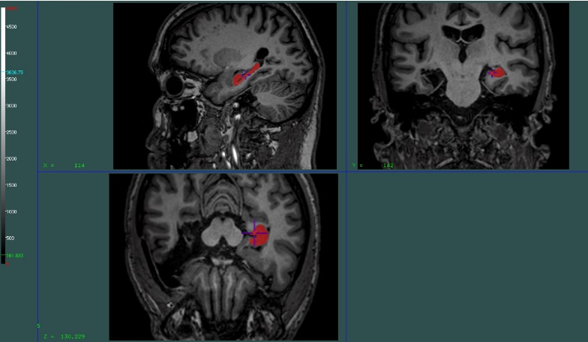 | 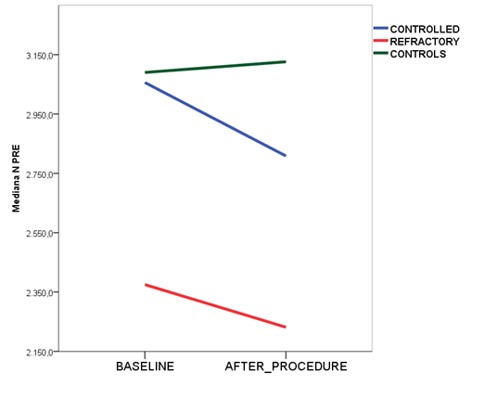
- Software DISPLAY. Manual segmentation of right hippocampus in red. | - Evaluation of long-term volumetry in patients (controlled / refractory) and controls.

Discussion: Significant contralateral hippocampal atrophy occurs following MTLE surgery, however few studies have performed long-term evaluation to investigate this process. A speculative explanation for the mechanisms of this reduction could be an association with the deafferentation process triggered after severing the connections between both hippocampi via surgical intervention.

Conclusion: We demonstrated that manual volumetry can reveal a reduction in contralateral hippocampal volume that could not be detected in visual analysis. These findings suggest that dynamic processes persist after the removal of the hippocampus, and further studies with larger groups may help to understand underlying mechanisms.

References: [1] Bonilha, L., et al., 2004. Hum Brain Mapp 22, 145-54; [2] Cendes, F., et al., 1993. Ann Neurol 34, 795-801; [3] Elliot, A.C., et al., 2016. Epilepsy Research 125 (2016) 62-71; [4] Fernandes, D.A., et al., 2014. Epilepsy Behav 36, 108-14; [5] Noulhiane M, Samson S, Clemenceau S, Dormont D, Baulac M, Hasboun D., 2006. J Neurosci Methods; 156;293-304; [6] Yasuda, C.L., et al., 2006. 15, 35-40.

