Method for motor cortex mapping using navigated transcranial magnetic stimulation
R. H. Matsuda¹, V.H. Souza¹, V.V. Cuziol¹, O. Baffa¹
¹Laboratório de Biomagnetismo, DF, FFCLRP, USP-RP

Introduction: Neuronavigation systems are important for instantaneous localization of brain structures with high accuracy during transcranial magnetic stimulation procedures, named navigated TMS (nTMS). One of the main applications of nTMS is identify the cortex area responsible to control a certain muscle mapping the motor cortex representation [2]. However, there is still no consensus in literature about the best methods to define the mapping area and errors associated to nTMS [3]. The aim of this study was to develop a method to create a map of cortical motor representation of hand and forearm muscles and analyze the stimulus variability during motor mapping procedures.
Materials and Methods: Thirteen healthy and right-handed subjects underwent nTMS motor mapping for the right flexor pollicis brevis (FPB), abductor digiti minimi (ADM) and flexor carpi radialis (FCR) on the left hemisphere. All subjects’ images were acquired in a 3T MRI scanner (Philips Achieva, Netherlands). The motor evoked potential (MEP) were recorded with electrodes in monopolar configuration digitized and amplified by EMG410C (EMGSystem, Brazil). Stimulation was performed using a figure-of-eight coil connected to the Neuro-MS (Neurosoft, Russia) stimulator. Finally, InVesalius Navigator [https://github.com/biomaglab/invesalius3] with MicronTracker (ClaroNav, Canada) was used for real time neuronavigation. Motor mapping session consisted in applying TMS pulse at 20 coordinates around each muscle hotspot (Figure 1). Three pulses were applied to each coordinate, and MEPs of all three muscles were recorded simultaneously. This procedure was conducted for the three hotspots muscles and for each subject, repeated in two different days. For each site, the Euclidean distance between all three stimuli coordinates were calculated to estimate the variability of mapping procedure.
Results: Peak-to-peak amplitude of each MEP was normalized, interpolated and projected over the polygonal mesh of a segmented cortical surface (Figure 2). Resulting map provides visual feedback of cortical region associated to targeted muscle. Estimated variability for each site was 3.5 ± 2.1 mm.
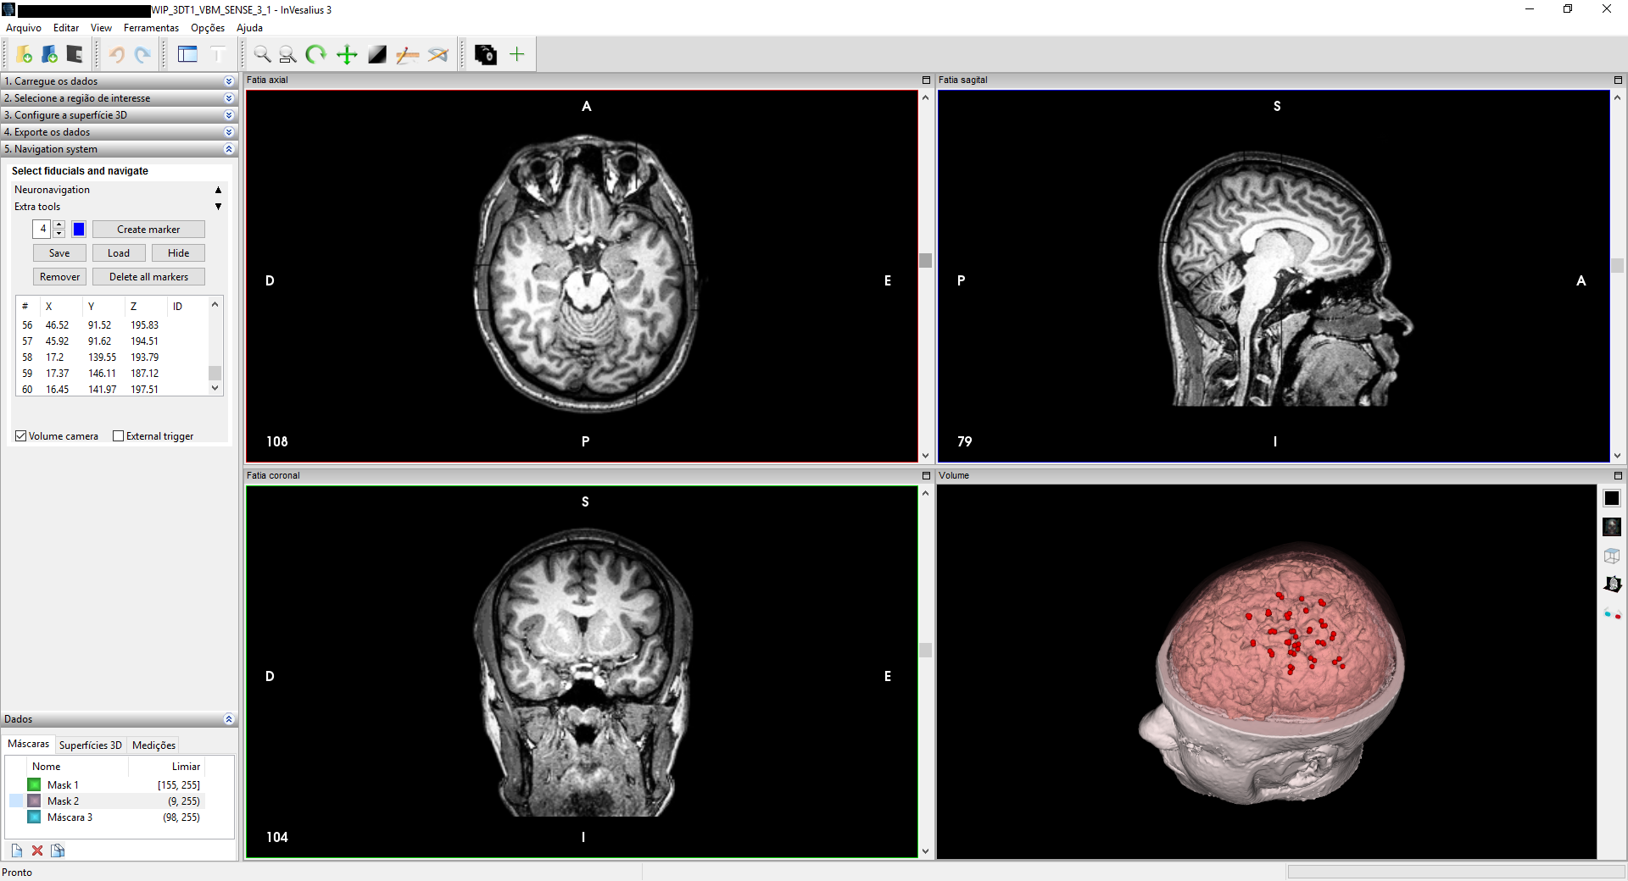
Figure 1: InVesalius Navigator

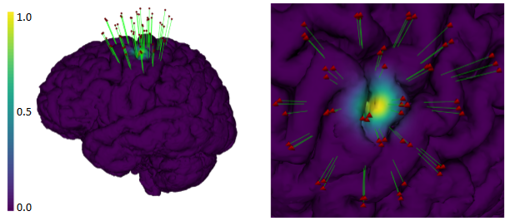

Figure 2: Cortical map of representative subject. Red dots represent the stimulus coordinates

Discussion: Estimated variability of consecutive coordinates were greater than the total InVesalius Navigator accuracy, i.e. 2.6 ± 0.4 mm. Thus, it is most likely that this increase in variation is associated to low frequency movements of coil during manual mapping procedure. Small coil movements may affect an accurate definition of the mapping area and probably contribute to a greater variability in MEP responses. This highlight the necessity of a nTMS system to take the coordinate variability while generating the motor mapping. Our study is still under development and next step will target a definition of mapping features over realistic cortical surface.
Conclusion: The present method allows the integration of motor mapping procedures to the InVesalius Navigator software and highlight the importance of neuronavigation to understand the TMS variability.
References: [1] Grunert P et al., Neurosurg Rev 26: 73-99, 2003; [2] Sollmann N et al., BMC Neuroscience 14:94, 2013; [3] Julkunen P et al., NeuroImage 790-795, 2009;

