Altered connectivity of language-related areas in high-functioning autism

B.M. Campos¹, A. Pereira², TM. Lopes¹, L.F.L. Pegoraro³, F. Cendes¹
¹Neuroimaging Lab., FCM, Unicamp, ²Pediatrics Dept., PUC-Rio Grande do Sul, ³Psychiatry Dept., FCM, Unicamp
Introduction: High-functioning autism (HFA) represents a complex neurodevelopmental condition characterized by deficits in communication and social behaviors but with normal global IQ [1]. We studied the functional connectivity at rest in known areas associated with language function, exploring the human communication systems (gestural/facial, verbal and writing).
Materials and Methods: We included 29 controls and 22 young patients with HFA. An anatomical (T1WI) and the resting state fMRI of all volunteers were included. The analysis was fully performed with UF²C-Toolbox and is briefly described as: dynamics realignment, co-registration, normalization, smoothing, regression for 6 head motion parameters and WM/CSF average series, detrend and band-pass filter [2]. On the first level analysis, we generated individual matrices based on the pair-wise correlation of the BOLD time series from eight left hemisphere cubic (1 cm³) ROIs: Wernicke’s area (WA); Heschl’s gyrus; ant. sup. temporal gyrus; ant. mid. temporal gyrus (AMTG); Broca’s area; ant./mid. fusiform gyrus (face form area [FFA]); post. fusiform gyrus (visual word form area [VWFA]); and the temporal pole. In the second level analysis, we applied an ANCOVA to compare groups (ROI level, alpha=0.05 FDR-corrected, gender as covariate).
Results: We found two ROIs pairs with reduced FC in HFA: AMTG with WA and FFA with VWFA (Fig.)
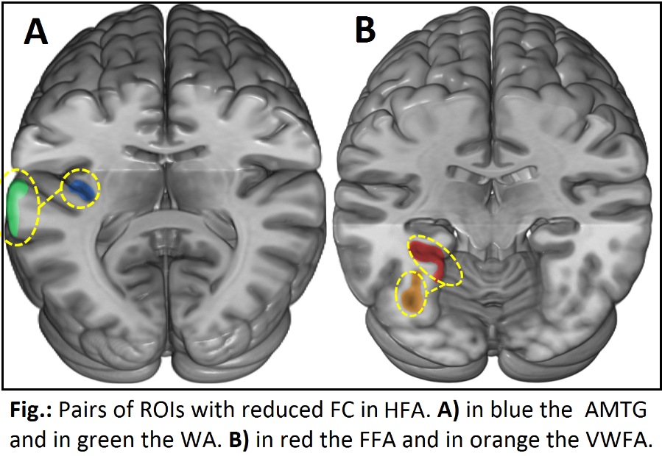
Discussion: The Wernicke’s area is accepted as a critical association area for speech comprehension and in part for production. Other studies indicated that the AMTG is also involved in comprehension. The FC reduction between these regions could indicate that the deficits in verbal communication skills in HFA may be related, with other factors, to a wrong semantic process and a lower cooperation between these areas. VWFA is associated to visual aspects of graphemes, useful for reading abilities requiring orthographic and phonological aspects, as well as semantic components. The VWFA is also related to a more complex language aspect: the mental inference from facial expressions of emotion. In the same direction, FFA is associated to the visual aspect of the faces recognition. Considering that people with HFA have impaired recognition of facial expressions, we could speculate that both regions need to be hemodynamically communicative for adequate performance of reading and emotional interpretation (and interaction) of facial expressions [3,4].
Conclusion: Our results suggest that the language impairment in HFA patients could be related to decreased FC within associative language areas. These findings reinforce the idea that hemodynamic pattern among brain regions ion the rest condition may reflect the dysfunctional behaviors.
References: [1] American Psychiatric Association; DSM-V development: Autism Spectrum Disorder (WebSite). [2] de Campos BM et al., Human brain map. 37(9) 3137-52, 2016. [3] Saygin ZM et al., Nature 19(9), 1250-59 2016. [4] Dehaene S et al., Nature 19(9) 1192-4, 2016.

