Novel Interaction Techniques for Neurosurgical Planning

D. Oliveira³, W. S. Loos¹ , S.-T. Wu¹, E. Ghizoni^{2,3},
¹Computer Engineering and Automation Dept., FEEC, Unicamp, ²Neuroimages Laboratory, FCM, Unicamp, ³Dept. of Neurology, FCM, Unicamp

Introduction: Small and under surface lesions, infiltrating lesions and near eloquent areas lesions of the brain are quite challenging to the neurosurgeon perform a safe resection. Mastery of neuroanatomy and meticulous neurosurgical planning are the fundamental keys for surgical success. Sulci and giri surface anatomy is not always evident on the craniotomy field and even with a neuronavigating system one can become insecure about the correct localization of the lesions and eloquent brain areas. Superficial veins of the brain can, however, be visualized pre- and intra-operatively. Therefore, the relations between veins and brain anatomy are helpful in neuroanatomy recognition during pre-operative planning. On top of the well-established curvilinear reformatting tool for locating lesions in the prototype VMTK [1], we build an interactive interface. This interface not only provides a view of the brain and veins that a neurosurgeon has in the operating field, but also improves the exploration of the underlying anatomical structure as well. Based on the information gathered from the visual exploration, the neurosurgeon can identify the anatomy and perform a safe surgery.

Materials and Methods: We assess prospectively the usefulness of the developed tool in brain surgery planning. After loading contrast enhanced T1-weighted magnetic resonance imaging volume of a patient, the display of the blood vessels and the relevant anatomical fiducial marks must be improved by adjusting color and opacity of tissues. Then, scalp is cropped off for revealing the underlying region of interest into which the neurosurgeon can navigate with cursors, explore its surrounding eloquent structures and assess its position relative to the anatomical fiducial marks. This tool was initially used in four patients with supratentorial lesions who underwent surgery in the University of Campinas General Hospital from January to February 2017.

Results: The patients have small and under surface lesions. Surgical planning was performed using VMTK and intra-operative images were acquired to compare veins and brain surface with that produced by the software. Relations between veins and brain surface obtained by VMTK showed to be very reliable with that visualized on surgery, as illustrate the images on the right side.
Figure 1: comparison of the image created by the VMTK and the brain surface found in the surgery.
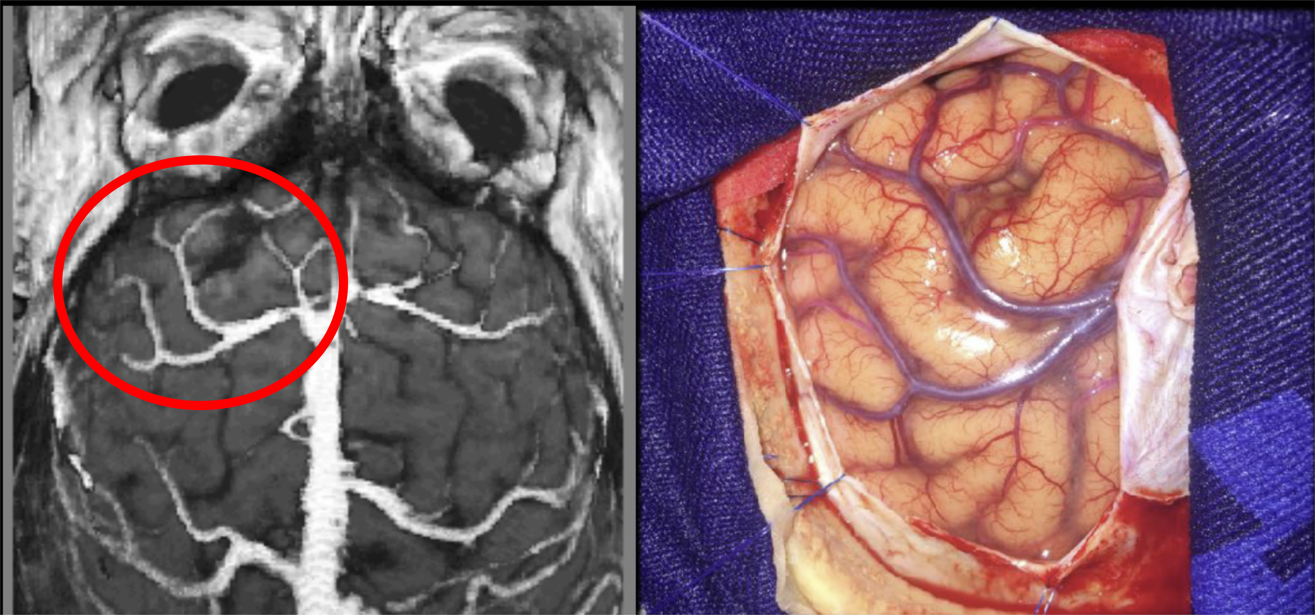

Discussion: Neuronavigation systems are very useful to locate brain lesions, but are still expensive and is subject to errors like brain shifting. Moreover, they do not provide a real 3D reconstruction of the brain surface and the surgeon must perform a 3D reconstruction in his mind from axial, coronal and sagittal slices. VMTK showed to be an important tool to neurosurgical planning, since its curvilinear reformatting tool performed in the patient native space is fundamental for the correct interpretation of brain surface anatomy.

Conclusion: VMTK can be an important tool for neurosurgical planning, bringing benefits to patients. It can help to define a craniotomy basis and to identify the brain surface anatomy. This software can be used in conjunction with a neuronavigation system or alone, and, once it is a free software, can be very useful in low income countries.

References: [1] Wu et al.
VMTK.http://www.dca.fee.unicamp.br/projects/mtk/wu_loos_voltoline_rubianes/index.html

