Functional connectivity of Default Mode Network in ischemic stroke: a prospective study

J. E. Vicentini¹, S.R.M. de Almeida, B.M. de Campos, L. Valler, L. M. Li¹
¹ Neurology Dept., FCM, UNICAMP

Introduction: Brain reorganization is a fundamental mechanism during patient recovery after a stroke, since it involves the capacity of brain to restore itself or compensate for damage caused by the lesion. Resting-state functional connectivity is defined as a temporal correlation between spatially remote regions of brain [1]. The Default Mode Network (DMN) is one of most prominent resting-state functional network of the brain and it has been associated to self-referential processing, as cognitive and emotional skills [2]. We aimed to explore the mechanism of DMN functional connectivity recovery in ischemic stroke through a longitudinal study.
Materials and Methods: This study was approved by the Ethics Committee and all individuals provided written consent to participate. Twenty stroke patients aged between 45-80 years old who had experienced their first-ever ischemia, without previous neurological history, were submitted to functional Magnetic Resonance Imaging (fMRI) acquisition using a 3T scanner (Philips Achieva®) on their first and sixth month after stroke. Image processing based on realignment, segmentation, normalization (MNI-152) and smoothing used UF²C (User Friendly Functional Connectivity) toolbox. Paired t-test performed in SPM12 for MATLAB followed the parameters of p<0.001 uncorrected and cluster size with at least 50 voxels.
Results: We found an increased connectivity of DMN functional connectivity in posterior cingulate cortex (PCC) (table 1 and figure 1) in first month post stroke, when compared to six months after ictus.
Table 1 Coordinates and cluster size of increased DMN functional connectivity on the first month after stroke in comparison with the sixth month (p<0.001, uncorrected)
 |  | Stereotaxic coordinates (mm)
Cluster size | Region | X | Y | Z | T value
212 | Posterior Cingulate Cortex | -2 | -48 | 24 | 4.35
Figure 1 Paired t-test results showed increased DMN functional connectivity in the sub acute stage, which was restored after six months (p<0.001, uncorrected)
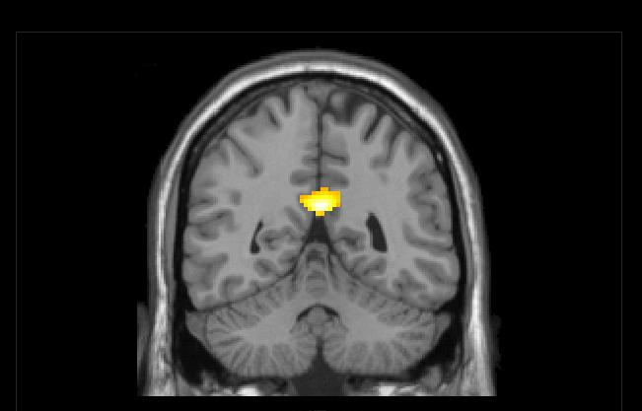
Discussion: Increased DMN functional connectivity on the first month after ictus suggests failure to suppress activity in some of the core region of DMN, which is associated with self-referential processing [3]. However, six months after stroke, there is a functional improvement in this network, suggesting that the first six months are a critical period for neural reorganization [4].
Conclusion: Abnormal DMN was found following stroke in sub acute stage. There was a natural recovery of this network six months post stroke. Our findings are exploratory, and further research may facilitate the understanding of potential mechanisms underlying self-referential processing in stroke recovery.
References: [1] Raichle ME et al., PNAS 98: 676-682, 2001; [2] Greicius et al., PNAS 101: 4637-4642, 2004 [3] Grady CL et al., Cogn Neurosci 18: 227-241, 2006 [4] Park et al., Eur J Neurosci 40: 2715-2722.

